

**DEPT. Of Computer Science Engineering**

**SRM IST, Kattankulathur – 603 203**

**Sub Code & Name: 18CSS201J - ANALOG AND DIGITAL ELECTRONICS**

|  |  |
| --- | --- |
| **Experiment No** | 03 |
| **Title of Experiment** | Design and implement a rectangular waveform generator (Op-Amp relaxation oscillator) using a simulation package and demonstrate the working of it |
| **Name of the candidate** |  |
| **Register Number** |  |
| **Date of Experiment** |  |

**Mark Split Up**

|  |  |  |  |
| --- | --- | --- | --- |
| **S.No** | **Description** | **Maximum Mark** | **Mark Obtained** |
| 1 | Oral Viva | 5 |  |
| 2 | Execution | 10 |  |
| 3 | Model Calculation / Result Analysis | 5 |  |
| **Total** | | **20** |  |

**Staff Signature with date**

**Design and implement a rectangular waveform generator (Op-Amp relaxation oscillator) using a simulation package and demonstrate the working of it**

**Aim**

To design and implement a rectangular waveform generator (Op-Amp relaxation oscillator) using a simulation package and demonstrate the working of it.

**Apparatus Required**

|  |  |  |  |  |
| --- | --- | --- | --- | --- |
| S.No | Apparatus | Type | Range | Quantity |
| 1 | OP-AMP | IC741 |  | 1 |
| 2 | Resistor |  | 1 kΩ, 1 kΩ, 100 kΩ | Each 1 |
| 3 | Capacitor |  | 10 nF | 1 |
| 4 | Voltage source |  | 12 V DC | 2 |
| 5 | Voltage probe |  |  | 1 |

**Software Required**

<https://www.multisim.com/>

**Theory**

Rectangular Waves are generated when the Op-Amp is forced to operate in the saturation region. That is, the output of the op-amp is forced to swing respectively between +Vsat And -Vsat resulting in the generation of square wave. The square wave generator is also called a free-running or astable Multivibrator Assuming the voltage across capacitor C is zero at the instant the d.c Supply voltage at +Vcc and VEE are applied. Initially the capacitance C acts, as a short circuit. The gain of the Op-Amp is very large hence V1 drives the output of the Op-Amp to its saturation.

**Procedure**

1. Make the connections as per the circuit diagram.
2. Adjust the values of resister and capacitor to the desired value.
3. Measure the output voltage using voltage probe and obtain the graph in grapher window.
4. Tabulate the readings.

**Circuit Diagram**

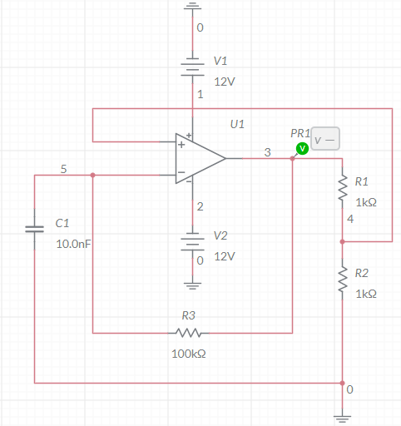

**Model graph**

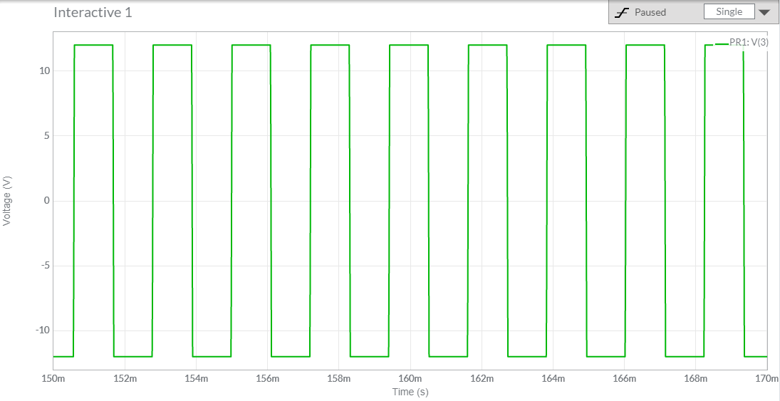

**Simulation waveform**

**Tabulation**

|  |  |  |
| --- | --- | --- |
| **Amplitude(V)** | **Time period (ms)** | **Frequency (Hz)** |
|  |  |  |

**Result**

Thus, the rectangular wave generator was designed, and the corresponding values are tabulated.